Multiple Choice Questions

1) | The oxidation reactions that convert pyruvate to CO₂ are specifically catalyzed by ______ enzymes.

A) | oxygenase
B) | oxidase
C) | decarboxylase
D) | dehydrogenase
E) | none of the above

Answer: D

Difficulty: 1 Topic: Overview of Pyruvate Oxidation and the Citric Acid Cycle

2) | In the citric acid cycle, acetyl-CoA reacts with ________ to produce _________.

A) | fumarate; α-ketoglutarate
B) | oxaloacetate; citrate
C) | citrate; isocitrate
D) | succinyl-CoA; oxaloacetate
E) | malate; cis-aconitate

Answer: B

Difficulty: 2 Topic: Overview of Pyruvate Oxidation and the Citric Acid Cycle

3) | For each molecule of acetyl-CoA that enters the citric acid cycle, which of the following best represents the net products of the cycle?

A) | 2 CO₂, 2 NADH, 2 FADH₂, 1 GTP, 1 oxaloacetate
B) | 1 CO₂, 3 NADH, 1 FADH₂, 2 GTP, 1 oxaloacetate
C) | 2 CO₂, 3 NADH, 1 FADH₂, 1 GTP, 0 oxaloacetate
D) | 1 CO₂, 2 NADH, 1 FADH₂, 2 GTP, 0 oxaloacetate
E) | 2 CO₂, 3 NADH, 1 FADH₂, 1 GTP, 1 oxaloacetate

Answer: C

Difficulty: 2 Topic: Overview of Pyruvate Oxidation and the Citric Acid Cycle

4) | Which of the following coenzymes is required for the decarboxylation of pyruvate by the pyruvate dehydrogenase complex?

A) | thiamine pyrophosphate
B) | coenzyme A
C) | lipoic acid
D) | NAD⁺
E) | FAD

Answer: A

Difficulty: 1 Topic: Pyruvate Oxidation

5) | Which of the following enzymes of the pyruvate dehydrogenase complex is responsible for the oxidation of the hydroxyethyl group from pyruvate decarboxylation to an acetyl group?

A) | pyruvate dehydrogenase
B) | dihydrolipoamide transacetylase
C) | dihydrolipoamide dehydrogenase
D) | pyruvate dehydrogenase kinase
E) | pyruvate dehydrogenase phosphatase

Answer: B

Difficulty: 2 Topic: Pyruvate Oxidation

6) | Which of the following best explains why thioesters have a greater free energy of hydrolysis than ordinary esters?

A) | alcohols are better leaving groups than thiols
B) | oxygen is more electronegative than sulfur
C) | esters are resonance stabilized while thioesters are not
D) | the oxygen of an ester is more easily protonated than the sulfur of a thioester
E) | none of the above

Answer: C

Difficulty: 2 Topic: Coenzymes Involved in Pyruvate Oxidation

7) | Which of the following correctly lists the products of the pyruvate dehydrogenase complex in the correct order of release?

A) | acetyl-CoA, CO₂, NADH
B) | acetyl-CoA, CO₂, FADH₂
C) | CO₂, acetyl-CoA, NADH
D) | CO₂, acetyl-CoA, FADH₂
E) | CO₂, acetyl-CoA, FADH₂, NADH

Answer: C

Difficulty: 2 Topic: Action of the Pyruvate Dehydrogenase Complex

8) | Arsenic poisoning by either arsenite or organic arsenical agents work by binding to dithiol compounds such as _________ meaning that in addition to inactivation of pyruvate dehydrogenase, the citric acid cycle enzyme _________ would be inactivated.

A) | cysteine; aconitase
B) | coenzyme A; α-ketoglutarate dehydrogenase
C) | coenzyme A; citrate synthase
D) | thiamine pyrophosphate; isocitrate dehydrogenase
E) | lipoic acid; α-ketoglutarate dehydrogenase

Answer: E

Difficulty: 2 Topic: Action of the Pyruvate Dehydrogenase Complex

9) | What role does the coenzyme A portion of acetyl-CoA play in the reaction catalyzed by citrate synthase?

A) | the CoA group causes the enzyme to close around the substrates, enabling catalysis
B) | lack of resonance in the thioester makes the methyl carbon of the acetyl group more acidic, allowing proton abstraction to readily occur
C) | CoA makes the carbonyl carbon highly susceptible to nucleophilic attack
D) | hydrolysis of the thioester makes the reaction essentially irreversible
E) | all of the above

Answer: E

Difficulty: 3 Topic: The Citric Acid Cycle

10) | The conversion of citrate to isocitrate by the enzyme aconitase is best described as ______ reaction consisting of a ________ followed by a ________.

A) | isomerization; oxidation; reduction
B) | isomerization; hydration; dehydration
C) | isomerization; dehydration; hydration
D) | group transfer; dehydroxylation; hydroxylation
E) | group transfer; hydroxylation; dehydroxylation

Answer: C

Difficulty: 2 Topic: The Citric Acid Cycle

11) | The two reactions of the citric acid cycle where CO₂ is produced are catalyzed by _________ and _________

A) | isocitrate dehydrogenase; α-ketoglutarate dehydrogenase
B) | isocitrate dehydrogenase; malate dehydrogenase
C) | α-ketoglutarate dehydrogenase; succinate dehydrogenase
D) | α-ketoglutarate dehydrogenase; malate dehydrogenase
E) | succinate dehydrogenase; malate dehydrogenase

Answer: A

Difficulty: 2 Topic: The Citric Acid Cycle

12) | Which of the following is an enzyme-bound intermediate in the reaction catalyzed by succinyl-CoA synthetase?

A) | succinyl phosphate
B) | glutamyl-CoA
C) | N-phosphohistidine
D) | N-ADP-histidine
E) | none of the above

Answer: C

Difficulty: 2 Topic: The Citric Acid Cycle

13) | Which oxidation reaction requires the coenzyme FAD because it involves oxidation of a carbon-carbon single bond to a double bond?

A) | oxidation of isocitrate to α-ketoglutarate
B) | oxidation of α-ketoglutarate to succinyl-CoA
C) | oxidation of succinate to fumarate
D) | oxidation of malate to oxaloacetate
E) | oxidation of pyruvate to acetyl-CoA

Answer: C

Difficulty: 2 Topic: The Citric Acid Cycle

14) | The complete oxidation of the acetyl group that enters the citric acid cycle yields _____ electrons from the methyl carbon and ____ electrons from the carbonyl carbon.

A) | 4; 2
B) | 6; 2
C) | 6; 4
D) | 8; 2
E) | 8; 2

Answer: B

Difficulty: 2 Topic: Stoichiometry and Energetics of the Citric Acid Cycle

15) | Which of the following is an equilibrium-controlled reaction of the citric acid cycle?

A) | citrate synthase
B) | isocitrate dehydrogenase
C) | α-ketoglutarate dehydrogenase
D) | succinate dehydrogenase
E) | all of the above

Answer: D

Difficulty: 2 Topic: Stoichiometry and Energetics of the Citric Acid Cycle

16) | Which of the following is an inhibitor of citrate synthase, isocitrate dehydrogenase, and α-ketoglutarate dehydrogenase?

A) | NADH
B) | succinyl-CoA
C) | ATP
D) | acetyl-CoA
E) | none of the above

Answer: A

Difficulty: 1 Topic: Regulation of Pyruvate Dehydrogenase and the Citric Acid Cycle

17) | __________ activates __________, thereby inhibiting pyruvate dehydrogenase.

A) | NADH; pyruvate dehydrogenase phosphatase
B) | Ca²⁺; pyruvate dehydrogenase phosphatase
C) | NAD⁺; pyruvate dehydrogenase kinase
D) | ATP; pyruvate dehydrogenase kinase
E) | pyruvate; pyruvate dehydrogenase kinase

Answer: D

Difficulty: 2 Topic: Regulation of Pyruvate Dehydrogenase and the Citric Acid Cycle

18) | Which of the following reactions is commonly used to replenish intermediates of the citric acid cycle?

A) | citrate → oxaloacetate + acetyl CoA
B) | oxaloacetate → aspartate
C) | glutamate → α-ketoglutarate
D) | malate → pyruvate
E) | all of the above

Answer: C

Difficulty: 2 Topic: Anaplerotic Sequences

19) | Which of the following molecules is correctly paired with the enzyme that can convert it to oxaloacetate to replenish the citric acid cycle when other intermediates are removed?

A) | aspartate: aspartate deaminase
B) | pyruvate: malic enzyme
C) | phosphoenolpyruvate: PEP carboxylase
D) | glutamate: glutamate transaminase
E) | none of the above

Answer: C

Difficulty: 3 Topic: Anaplerotic Sequences

20) | Which of the following citric acid cycle enzymes is bypassed in the glyoxylate cycle?

A) | citrate synthase
B) | aconitase
C) | isocitrate dehydrogenase
D) | succinate dehydrogenase
E) | fumarase

Answer: C

Difficulty: 2 Topic: Glyoxylate Cycle

21) | The reaction catalyzed by malate synthase is shown below. Which citric acid cycle enzyme would have a mechanism most similar to malate synthase?
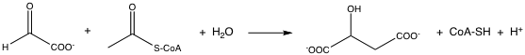
A) | malate dehydrogenase
B) | citrate synthase
C) | fumarase
D) | succinyl-CoA synthetase
E) | none of the above

Answer: B

Difficulty: 2 Topic: Glyoxylate Cycle

22) | What is the source of acetyl-CoA for the glyoxylate cycle?

A) | pyruvate
B) | amino acids
C) | fatty acids
D) | cholesterol
E) | all of the above

Answer: C

Difficulty: 1 Topic: Glyoxylate Cycle

Short Answer Questions

1) Draw the enzyme-bound intermediate of the following reaction clearly showing proper stereochemistry:

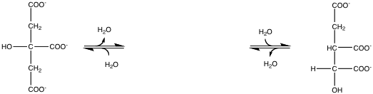

Answer:
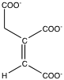

Difficulty: 3 Topic: The Citric Acid Cycle

2) The most common reactions of acetyl acetyl-CoA are with a nucleophile or with a base. Show the reactions of acetyl CoA with the generic base and the generic nucleophile:

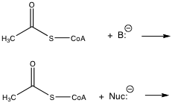

Answer:

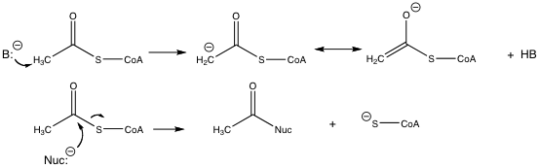

Difficulty: 2 Topic: The Citric Acid Cycle

3) The glyoxylate cycle reaction catalyzed by isocitrate lyase is a reversible aldol condensation. As it is written below, the reaction is an aldol cleavage. Propose a mechanism for this reaction using the acid and base supplied by the enzyme.

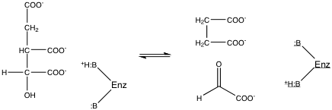

Answer:

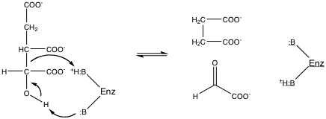

Difficulty: 3 Topic: Glyoxylate Cycle

